**STEPS**

1. Open Visual C++ and click the New item in the File menu and a new dialog box is opened
2. Now select “MFC AppWizard (exe)” entry
3. Give the new Project name in the Project name box and click OK. Clicking OK will start the Visual C++ AppWizard

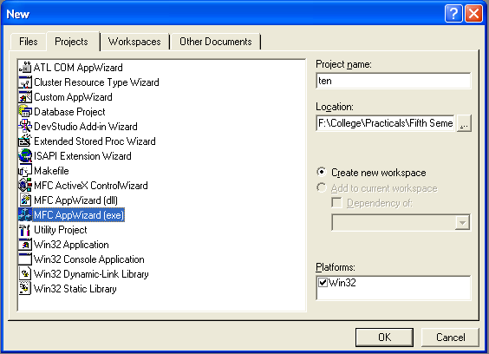

1. We will accept all defaults except one- by default, AppWizard creates Multiple Documents program and we will change so that it creates a Dialog Based program

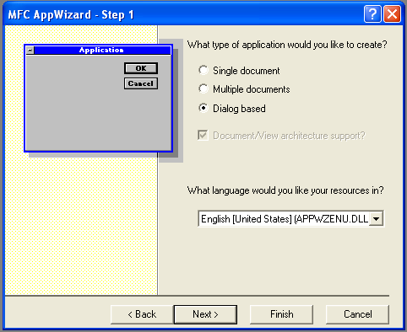

1. The AppWizard is asking for what database we want in our program; we will do “None” option selected. Keep pressing next until project information box is opened. A toolbar is shown and we can drag and drop the toolbar from toolbar menu to working station
2. Drag two Group Boxes and change there caption as Arrangements and Flowers
3. Drag four radio buttons in Arrangement Group box and change there names as “Type 1 to Type 4”. Drag four check boxes in Flowers Group box and change there names as “Roses”, “Lilies”, “Carnations” and “Petunias”
4. Drag one text box in which price of different types of arrangements are shown as per selection
5. In Class Wizard, select Member Variables tab. Click on first check box and click add variable button change variable name as m_check1 and as for all the check boxes. Also change variable name of rich box as m_text
6. Click on the first radio button and write these steps:

void CTenDlg::OnRadio1()

{

// TODO: Add your control notification handler code here

* m_check1=true;
* m_check2=true;
* m_check3=true;
* m_check4=true;
* m_text="$ 5.00";
* UpdateData(false);

}

Do these steps for next three radio buttons:

void CTenDlg::OnRadio2()

{

// TODO: Add your control notification handler code here

* m_check1=true;
* m_check2=false;
* m_check3=true;
* m_check4=false;
* m_text="$ 4.50";
* UpdateData(false);

}

void CTenDlg::OnRadio3()

{

// TODO: Add your control notification handler code here

* m_check1=false;
* m_check2=true;
* m_check3=false;
* m_check4=true;
* m_text="$ 3.25";
* UpdateData(false);

}

void CTenDlg::OnRadio4()

{

// TODO: Add your control notification handler code here

* m_check1=false;
* m_check2=false;
* m_check3=false;
* m_check4=false;
* m_text="$ 0.00";
* UpdateData(false);

}

1. Now run the program by Build Ten.exe and Execute Ten.exe item in the Build menu and type some text into it

**OUTPUT**

